[1] "Определитель матрицы T: -84"
[1] "Определитель матрицы A: 25"
[1] "Собственные значения: -10, -5, -1, -0.500000000000001"
[1] "Собственные векторы:"
[,1] [,2] [,3] [,4]
[1,] -0.6360352 9.124475e-16 -0.8271147 -0.5715476
[2,] 0.1590088 7.071068e-01 0.2067787 0.5715476
[3,] 0.5451730 -8.364102e-16 0.3544777 -0.4898979
[4,] -0.5224575 -7.071068e-01 0.3840175 0.3265986
[1] "Проверка корректности: TRUE"
[1] "Коэффициенты C:"
[1] 2.0963201 -0.3535534 -2.8210518 -1.7496355

> eigenvectors[1,]%*%C
[,1]
[1,] 2
> eigenvectors[2,]%*%C
[,1]
[1,] -1.5
> eigenvectors[3,]%*%C
[,1]
[1,] 1
> eigenvectors[4,]%*%C
[,1]
[1,] -2.5

> eigenvectors[1,]*C
[1] -1.333333e+00 -3.225989e-16 2.333333e+00 1.000000e+00
> eigenvectors[2,]*C
[1] 0.3333333 -0.2500000 -0.5833333 -1.0000000
> eigenvectors[3,]*C
[1] 1.142857e+00 2.957157e-16 -1.000000e+00 8.571429e-01
> eigenvectors[4,]*C
[1] -1.0952381 0.2500000 -1.0833333 -0.5714286

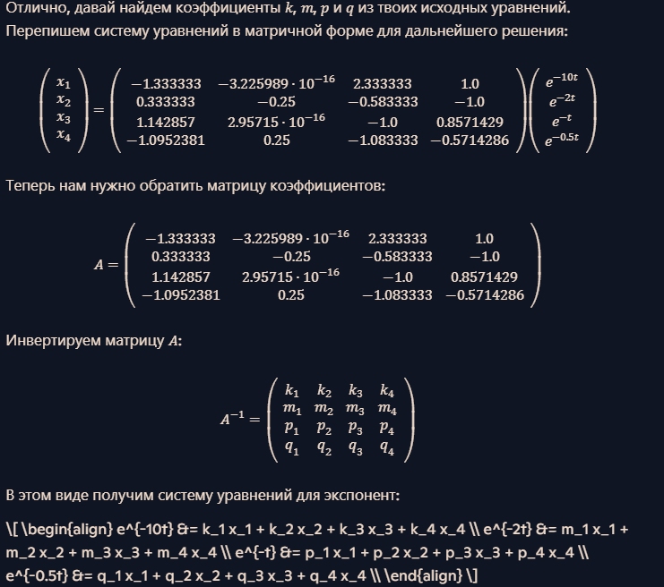
> A_inv
[,1] [,2] [,3] [,4]
[1,] -0.7500000 -0.7500001 -0.5000001 -0.7500001
[2,] -2.9999994 -4.9999997 -3.0000001 -0.9999997
[3,] -0.2857142 -0.5714286 -0.7142858 -0.5714286
[4,] 0.6666666 0.3333333 0.9999999 0.3333333
\[ \begin{align} e^{-10t} &= -0.75 x_1 - 0.75 x_2 - 0.50 x_3 - 0.75 x_4 \\ e^{-2t} &= -3.00 x_1 - 5.00 x_2 - 3.00 x_3 - 1.00 x_4 \\ e^{-t} &= -0.29 x_1 - 0.57 x_2 - 0.71 x_3 - 0.57 x_4 \\ e^{-0.5t} &= 0.67 x_1 + 0.33 x_2 + 1.00 x_3 + 0.33 x_4 \\ \end{align} \]

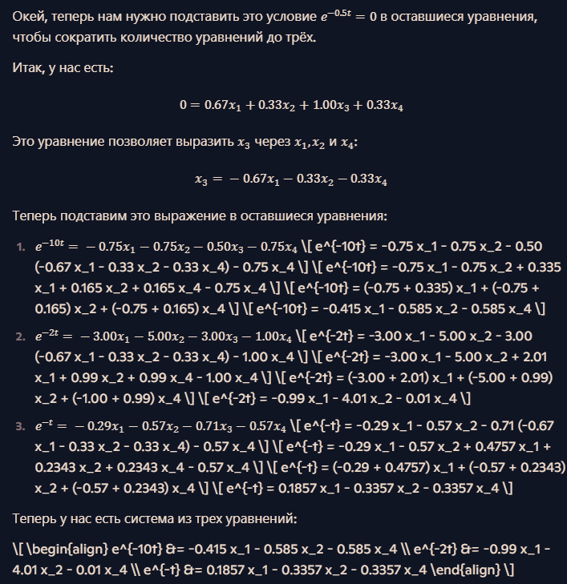\[ \begin{align} e^{-10t} &= -0.415 x_1 - 0.585 x_2 - 0.585 x_4 \\ e^{-2t} &= -0.99 x_1 - 4.01 x_2 - 0.01 x_4 \\ e^{-t} &= 0.1857 x_1 - 0.3357 x_2 - 0.3357 x_4 \end{align} \]
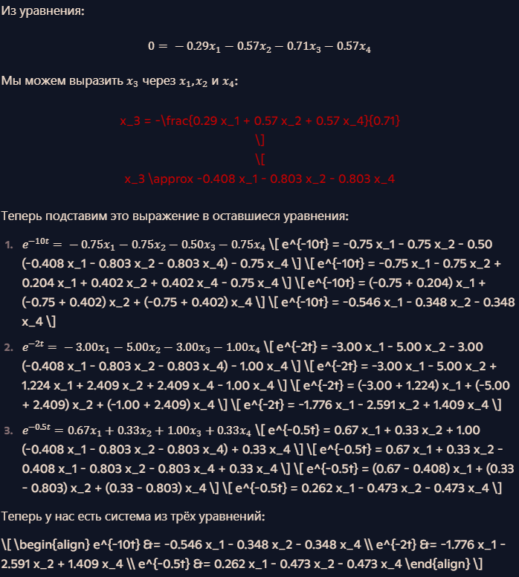
\[ \begin{align} e^{-10t} &= -0.546 x_1 - 0.348 x_2 - 0.348 x_4 \\ e^{-2t} &= -1.776 x_1 - 2.591 x_2 + 1.409 x_4 \\ e^{-0.5t} &= 0.262 x_1 - 0.473 x_2 - 0.473 x_4 \end{align} \]

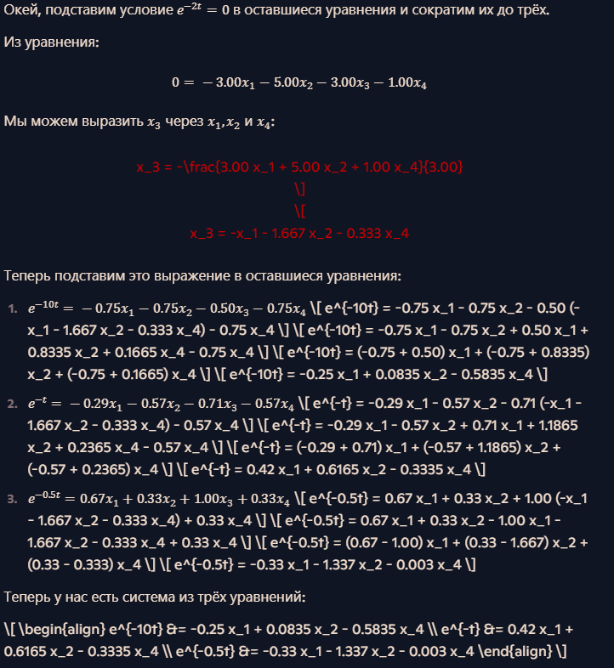
\[ \begin{align} e^{-10t} &= -0.25 x_1 + 0.0835 x_2 - 0.5835 x_4 \\ e^{-t} &= 0.42 x_1 + 0.6165 x_2 - 0.3335 x_4 \\ e^{-0.5t} &= -0.33 x_1 - 1.337 x_2 - 0.003 x_4 \end{align} \]
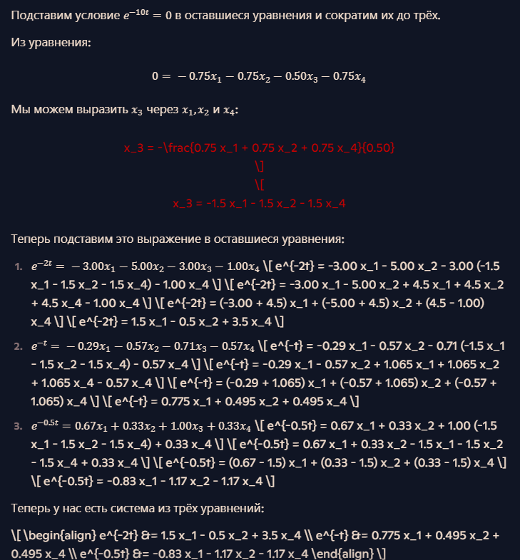
\[ \begin{align} e^{-2t} &= 1.5 x_1 - 0.5 x_2 + 3.5 x_4 \\ e^{-t} &= 0.775 x_1 + 0.495 x_2 + 0.495 x_4 \\ e^{-0.5t} &= -0.83 x_1 - 1.17 x_2 - 1.17 x_4 \end{align} \]

